For Immediate Release

Measured yet steady market stabilisation expected in a year of continued recovery, renewal and reset

HONG KONG, 18 January 2022 – Leading diversified professional services and investment management company Colliers (NASDAQ and TSX: CIGI) has released its Hong Kong Market Outlook report for 2022. The company forecasts 2022 to be a year of measured but steady recovery across many of the city’s property sectors.
“Hong Kong’s economy grew by 7% GDP year-on-year in the first three quarters of 2021. Given the current context, we expect a more moderate start in Q1 2022, with momentum gathering pace in Q2 2022 onwards. With prices and rents having reset to a more attractive level, this is a good time for investors and occupiers to drive their real estate strategies and capitalise on growth opportunities,” said Rosanna Tang, Head of Research, Hong Kong & Greater Bay Area.
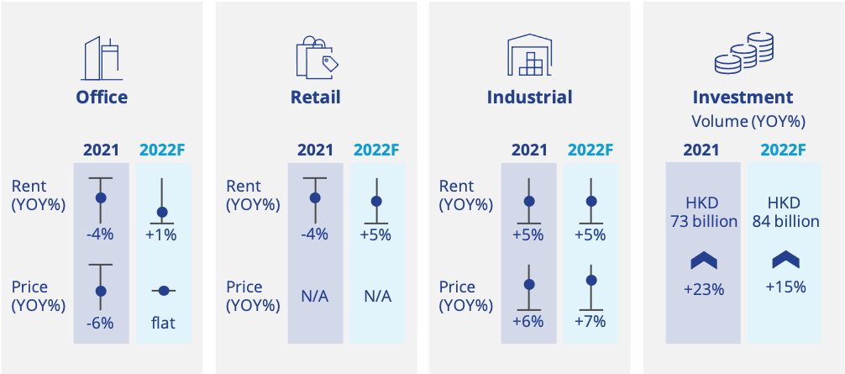
Source: Colliers’ property market summary for Hong Kong in 2021 and forecast for 2022.
Office
Improved leasing sentiment saw overall office rents stabilise initially across key submarkets in 2021. However, with net demand remaining relatively sluggish, Colliers predicts Hong Kong’s Grade A office market will continue to be soft, as net rents remain relatively flat in 2022 with a slight upside of about 1%.
“We expect rental recovery in 2022 to look different across different submarkets. Outperforming districts will include Central/Admiralty and Tsim Sha Tsui, which are expected to pick up by 4% and 3% respectively. Submarkets like Island East and Kowloon East, which boast large new supply pipelines and higher vacancy rates, will likely experience rental corrections of -3% and -2.5%. With asset quality becoming an important criteria for occupiers, landlords, especially those with older buildings, need to be more proactive in refurbishing or future proofing their buildings to maintain competitiveness,” said Fiona Ngan, Head of Office Services at Colliers Hong Kong.
Industrial
The first commercial sector to rebound in 2021, Colliers expects the industrial market to continue to grow in 2022, with overall warehouse rents and prices to increase by 5% and 7% respectively.
“This year, the industrial leasing market continues to outperform after experiencing diversified sources of demand from different occupier's sectors due to increasing adoption of tech and e-commerce. Beyond traditional drivers like third-party logistics (3PL) providers, leasing demand in 2021 also derived from the F&B and technology side, with an increased demand for cold storage spaces, central kitchens and data centres. The ongoing solid export trade performance with the backdrop of limited new warehouse supply means investors should take advantage of conversion and redevelopment options,” said Rosanna Tang.
Retail
The Omicron variant in January 2022 will inevitably slow down the recovery process of the Hong Kong Retail Market. Re-tightening of social distancing rules will limit expansion and sales performance for F&B operators. Having said that, Colliers believes the retail market bottomed out in 2021, with total retail sales increasing by 8.3% YOY for the first 11 months. This was supported by improved market sentiment, shopping momentum and a better labour market. Local consumption is expected to remain the key driver of Hong Kong’s retail market in 2022, amid potentially prolonged travel restrictions this year.
“Subject to the containment of the Omicron variant and the easing of social distancing measures in Q1, we predict retail rents to pick up from 2021’s low base as prime retail rents gently recover within a 5% range. Performing neighbourhood malls may have a higher percentage of rental increase as more people are willing to spend and dine in non-traditional retail districts. Quality coffee shops, modern F&B, home living & electronics and lifestyle supermarkets will do sustainably well over the following twelve months while the luxury market will take time to fully recover,” said Cynthia Ng, Executive Director, Retail Services at Colliers Hong Kong.
Capital Markets and Investment
In a market seeing strong pent-up demand and high liquidity, investors appear to have a clear appetite for expanding and diversifying their portfolios. Although transaction volume is yet to return to pre-pandemic levels, Hong Kong’s investment transactions picked up from 2020, with 170 deals concluded in 2021 at a total value of HK$73.3 billion, an increase of 49% and 23% year-on-year respectively. Institutional investors conducted 69% of transactions in 2021, the majority of which focused on the industrial side.
“We expect transactions in 2022 to increase, with overall investment volumes predicted to grow by around 15%. Neighborhood retail and industrial spaces are increasingly popular as defensive options for investors, while strata-title offices, street shops and hotels are presenting more upside potential. Whilst residential demand remains very solid in Hong Kong, we are also seeing more investment funds partnering up with local developers on residential developments.” said Thomas Chak, Executive Director, Capital Market & Investment Services at Colliers Hong Kong.
Residential
Omicron is expected to have a short-lived impact on the sentiment of the residential sector, as pent-up demand and the low interest rate environment will keep housing prices strong, with Colliers predicting mild growth for the mass residential sector in 2022. Lease modification and land exchange proved a substantial contributor of private housing land supply in 2021, going against previous forecasts that pegged government land sales to be most impactful. By Q4 of the financial year 2021, lease modification and land exchange accounted for 57% of the whole year’s private housing supply (11,390 housing units), as compared to 17% (3,410 housing units) from government land sales.
“Long-term government initiatives such as the Northern Metropolis Development Strategy and Lantau Tomorrow Vision project will take at least a decade to bring into effect. In the short to medium term, private market forces should play a more prominent role in alleviating the housing shortage as new housing supply is limited in the near-term. Practices such as charging standard rate premiums for the redevelopment of agricultural lots, granting early approval on land exchange applications, and reviewing the Tso/Tong land sales arrangement to ease sales restrictions will prove invaluable for expediting housing land supply, especially in New Development Areas (NDAs),” said Dorothy Chow, Asia, Executive Director, Valuation & Advisory Services at Colliers.
-End-

Media Contact:
Alex Kaihau
Associate Director, Marketing & Communications, Hong Kong
Alex.Kaihau@colliers.com
+852 2822 0692

About Colliers
Colliers (NASDAQ, TSX: CIGI) is a leading diversified professional services and investment management company. With operations in 65 countries, our more than 15,000 enterprising professionals work collaboratively to provide expert advice to real estate occupiers, owners and investors. For more than 26 years, our experienced leadership with significant insider ownership has delivered compound annual investment returns of almost 20% for shareholders. With annualized revenues of $3.6 billion ($4.0 billion including affiliates) and $46 billion of assets under management, we maximize the potential of property and accelerate the success of our clients and our people. Learn more at corporate.colliers.com, Twitter @Colliers or LinkedIn.

