For Immediate Release

Real Estate Investment Sales in Southeast Asia Increase 16% Year-on-Year, with Industrial Dominating Across Most Markets
- Industrial investment sales volume surpasses office and retail sales for the first time in a decade
- Data center investments drive the increase, quadrupling 2023 volumes
- Southeast Asia’s strong fundamentals will support its long-term growth in the face of current global uncertainties
SINGAPORE, 24 April 2025 – Industrial investment sales volume has surpassed office and retail sales for the first time in a decade across Southeast Asia (SEA) as the impacts of supply chain diversification, the growing digital economy and hybrid work influence investor priorities.
Cushman & Wakefield’s third annual Southeast Asia Outlook report shows data centre investment volumes across the region increased more than four-fold to USD3.2 billion year-on-year, representing around 40% of total industrial sales volumes across the region through 2024. Singapore, Malaysia and Indonesia continue to lead in this sector, driven by strong infrastructure, increasing cloud adoption, and regulatory support for digital expansion.
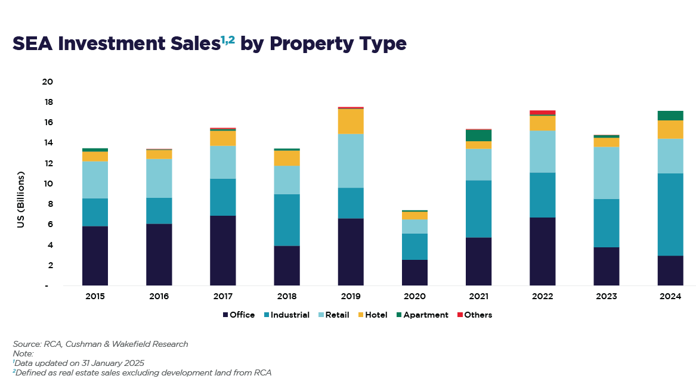

Anticipated export growth would continue to support industrial investment within SEA. The Southeast Asia region's 8% share of global exports in 2023 is poised for further growth, driven by its competitive costs, supply chain diversification, and increasing intra-regional trade in Asia Pacific. Thailand was the only market of those tracked by Cushman & Wakefield in SEA where industrial investment sales did not dominate, with hotels accounting for USD0.4 billion and industrial for USD0.2 billion.
Looking Ahead
SEA remains a key investment destination, and economic momentum remains steady, with projected GDP growth at 4.8% in 2024 surpassing the 3.9% growth recorded in 2023. Several major economies in the region, including Vietnam, Malaysia, and the Philippines, exceeded initial growth forecasts, reinforcing SEA’s resilience in the face of global headwinds.
Wong Xian Yang, Head of Research, Singapore & Southeast Asia and author of the report said:
"Despite the uncertainties in the global landscape due to the evolving tariff situation, Southeast Asia’s economic fundamentals remain steady, with resilient domestic consumption and a growing middle class. The region is poised to attract continued investment inflows, particularly in high-growth sectors. Industrial and data centres will remain top priorities for institutional investors, with increasing capital allocated to logistics, life sciences and AI-driven digital infrastructure.”
Investments into the office sector in Singapore and Indonesia are also gaining momentum, as investors capitalise on limited future supply and rising corporate demand for high-quality workspaces. Cross-border investments are expected to strengthen, driven by initiatives such as the Johor-Singapore Special Economic Zone (JS-SEZ) and expanding intra-ASEAN trade agreements.
"Southeast Asia’s resilience and strategic positioning make it a prime destination for global capital, but businesses must stay agile amid macroeconomic shifts," said Wong. "With strong economic fundamentals, the region’s cost advantages, supply chain diversification and expanding intra-regional trade will continue to drive long-term investment and real estate growth. Navigating global uncertainties with a strategic approach will be key to success in 2025 and beyond."
Please refer to the following pages for a summary of key points from the report. For the full report including individual Southeast Asia market snapshots, click here to download Cushman & Wakefield’s Southeast Asia Outlook 2025.

About Cushman & Wakefield
Cushman & Wakefield (NYSE: CWK) is a leading global commercial real estate services firm for property owners and occupiers with approximately 52,000 employees in nearly 400 offices and 60 countries. In 2024, the firm reported revenue of $9.4 billion across its core service lines of Services, Leasing, Capital markets, and Valuation and other. Built around the belief that Better never settles, the firm receives numerous industry and business accolades for its award-winning culture. For additional information, visit www.cushmanwakefield.com.
Key Economic Trends & Market Insights
1. Economic Resilience & Investment Growth
- Vietnam Leads Growth – Vietnam is expected to expand by 7% in 2024, fuelled by substantial foreign direct investment as it cements its status as a key electronics manufacturing hub in the region.
- Malaysia & Singapore Benefit from Electronics Demand – Both countries see supply chain diversification and high-value manufacturing investments driving their economies.
- Philippines’ BPO Boom – The contact center and business process outsourcing (BPO) industry is forecasted to generate USD32.16 billion in revenue in 2024, a 9% YoY increase.
- Indonesia's Stable Growth – With a young and growing population, Indonesia’s economy remains steady but faces challenges from cost-of-living pressures and rising taxes.
- Thailand’s Continued Recovery – Strengthening private consumption, increased manufacturing output and rebound in tourism support a positive growth trajectory.
2. Growth in Foreign Direct Investment (FDI)
- SEA’s FDI net inflows could reach a record high for the region in 2024.
- Indonesia is poised to attract record FDI levels, with strong inflows into metals, transportation and telecom sectors.
- Vietnam solidifies its position as a global electronics hub, with Amkor Technology and LG Display injecting substantial capital into expansion.
- Singapore remains SEA’s top FDI destination, with major investments in semiconductors and advanced manufacturing.
Real Estate Investment & Market Trends
1. Industrial & Logistics Drive Real Estate Investment Sales
- Real estate investment sales in SEA reached USD17.2 billion in 2024, a 16% YoY increase, despite high interest rates.
- Industrial investments outpaced office and retail for the first time in a decade, reflecting the sector’s growing appeal.
- Data centre investments surged USD$3.2 billion, with Singapore, Malaysia and Indonesia leading the charge.
- E-commerce continues to fuel demand for logistics space, with SEA’s digital economy projected to reach USD1 trillion by 2030.
2. Johor-Singapore Special Economic Zone (JS-SEZ) to Boost Cross-Border Investments
- The landmark JS-SEZ agreement aims to enhance cross-border connectivity, attract supply chain investments and strengthen the Singapore-Malaysia economic corridor.
- Singapore to retain high-value manufacturing, while Johor benefits from land-intensive industries such as assembly, food processing and logistics.
- Industrial and property markets in both countries set to benefit, with greater business integration and workforce mobility.
3. Office Market Shifts Amid Hybrid Work Trends
- Office investment volumes declined by over 20% in 2024, reflecting investor concerns about long-term hybrid work adoption.
- Singapore’s office market sees rising rents due to a constrained supply pipeline and steady demand for premium office space.
- Jakarta’s office rents are projected to grow by 8.5% annually from 2025 to 2029, amid tight supply conditions.
5. Retail & Hospitality Sectors Gain Momentum
- Prime retail rents are rising across most major markets in SEA, driven by resilient domestic consumption and tourism recovery.
- Luxury hotels and wellness tourism gain traction, with Thailand, Bali and Vietnam seeing rising demand for medical and wellness tourism.
- Hotel investment sales doubled in 2024, supported by MICE (meetings, incentives, conferences and exhibitions) events, concerts, and sports tourism.

-END-

